Project: Assignment 4.2
Course: CSD-380
Description: Test Plan to Run Against ToDo Application
Date: 09/03/2026
Samuel Sidzyik.
TABLE OF CONTENTS
Create a ToDo Item 2
Edit a Todo task item 3
Delete a Todo item 4
Test Blanks 5
Test URL and bad URL screen 6

Test 1 | Create a ToDo Item
 | Test Objective: Verifies a user can add items to the todo list | Developer: Sam Sidzyik  Date tested: 09/03/2026 | Peer tester: Ryan Barber  Date tested: 9/9/2026
Step | Action | Expected results: | Developer pass/fail | Tester pass/fail  + Screenshot
1 | Go to the webpage https://buwebdev.github.io/todo/ | Webpage Loads | Yes | Yes  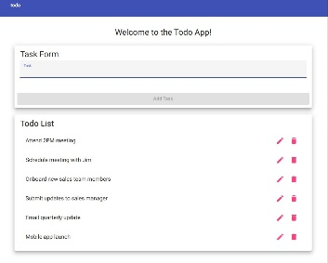
2 | Enter data into the task field | The field can be typed in | Yes | Yes  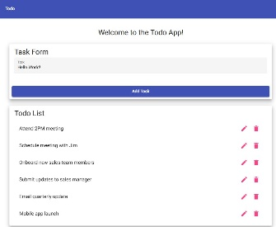
3 | Click “Add Task” | The task is created and can be seen in the list below | Yes | Yes
Comments | I was able to navigate to the webpage. The task field was redded out until being typed in. Once typed, the field became blue  , and the button became clickable. Clicking the button added what was written to the bottom of the list. |  |  | Everything worked as expected.

Test 2 | Edit a Todo task item
 | Test Objective: | Developer: Sam Sidzyik  Date tested: 09/03/2026 | Peer tester: Ryan Barber  Date tested: 9/9/2026
Step | Action | Expected results: | Developer pass/fail | Tester pass/fail
1 | Go to the webpage https://buwebdev.github.io/todo/ | Webpage Loads | Yes | Yes  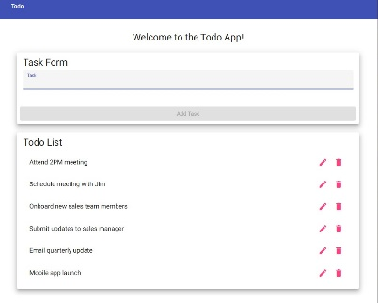
2 | Click the pencil on the list item to edit | Pop-up occurs to edit item | Yes | Yes  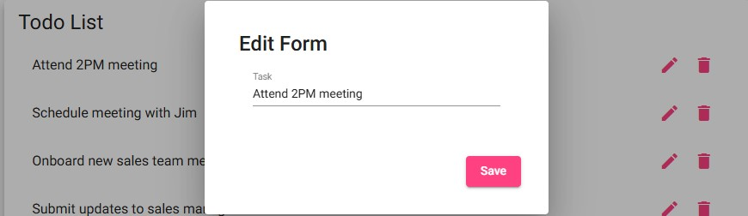
3 | Attempt to add 100 characters in the prompt | Character limit reached | No | No  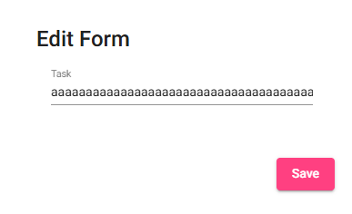
5 | Enter a SQL command | Blocks the command | No | No  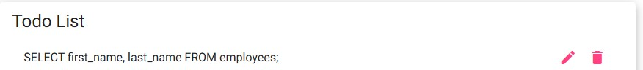
Comments | Line items are editable. Only prevents null operations

Test 3 | Delete a Todo item
 | Test Objective: Validate that Todo items can be deleted without issues | Developer: Sam Sidzyik  Date tested: 09/03/2026 | Peer tester: Ryan Barber  Date tested: 9/9/2026
Step | Action | Expected results: | Developer pass/fail | Tester pass/fail
1 | Go to the webpage https://buwebdev.github.io/todo/ | Webpage Loads | Yes | Yes  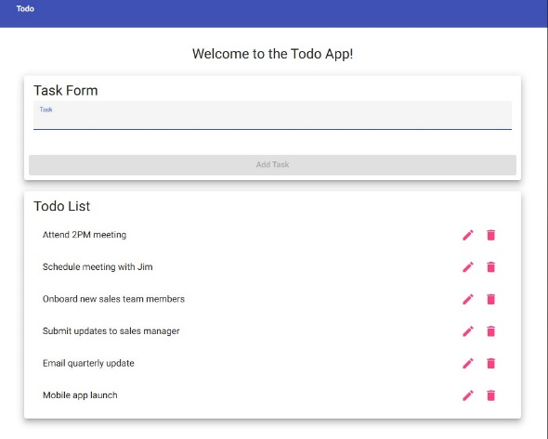
2 | Click the trashcan icon for an existing line item | Item is deleted | Yes | Yes  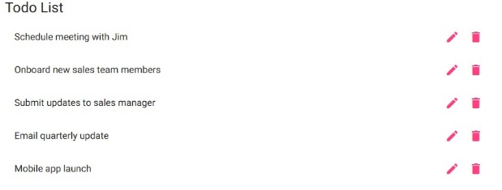
3 | Create a new line item and try to delete that one | Item is deleted | Yes | Yes  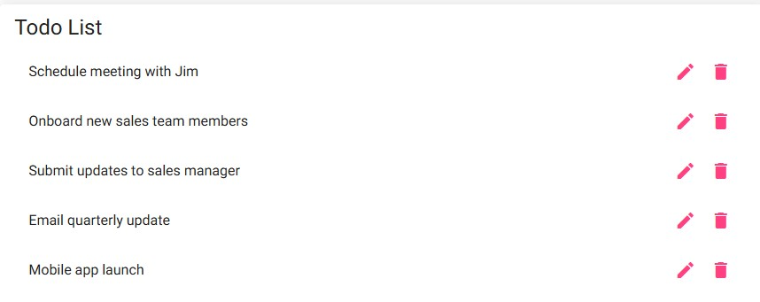
4 | Delete ALL line items | Every item can be deleted | Yes | Yes  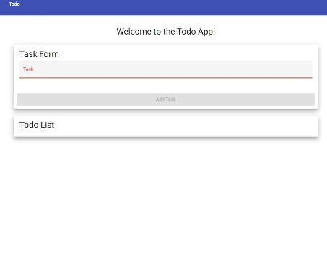
Comments | Deleting line items experienced no errors. Old, New, or ALL items can be deleted.

Test 4 | Test Blanks
 | Test Objective: Try to enter no data for a new task and edit the task | Developer: Sam Sidzyik  Date tested: 09/03/2026 | Peer tester: Ryan Barber  Date tested: 9/9/2026
Step | Action | Expected results: | Developer pass/fail | Tester pass/fail
1 | Go to the webpage https://buwebdev.github.io/todo/ | Webpage Loads | Yes | Yes  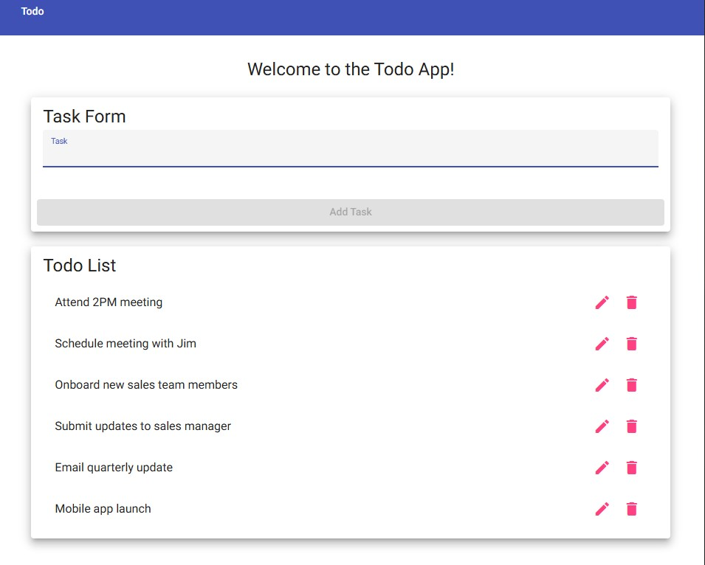
2 | Attempt to create a blank task | Does not allow | Yes | Yes  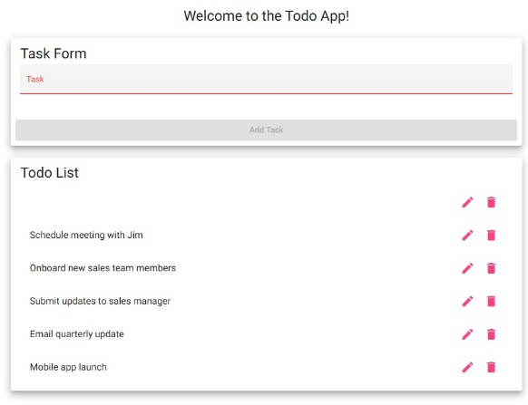
3 | Attempt to edit a task with no value | Does not allow | No | No  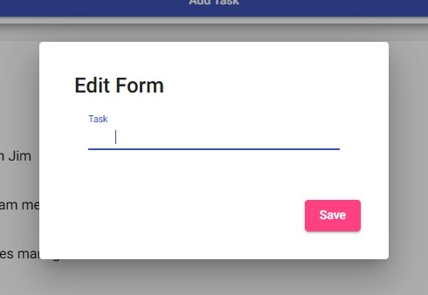
4 | Attempt to only use spaces for a new task | Does not allow | Yes | No  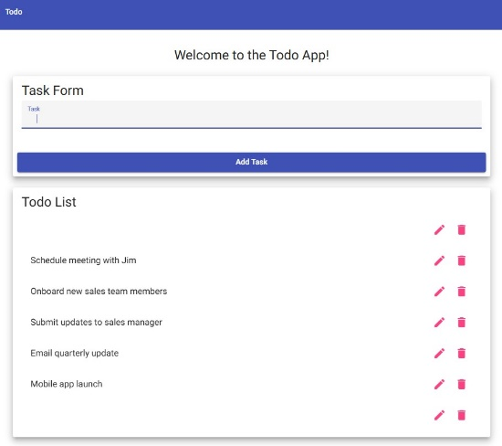
5 | Attempt to only use spaces for editing task | Does not allow | No | No
Comments | Attempted to add new task with no value and the button is not clickable. Attempted to edit task with no value and it accepted it… Attempted to add new task with only spaces and button not clickable. Attempted to edit task with only spaces and it accepted it.

Test 5 | Test URL and bad URL screen
 | Test Objective: Verify the page loads for good URLs and has a valid 404 site for bad URLs | Developer: Sam Sidzyik  Date tested: 09/03/2026 | Peer tester: Ryan Barber  Date tested: 9/9/2026
Step | Action | Expected results: | Developer pass/fail | Tester pass/fail
1 | Navigate to https://buwebdev.github.io/todo/ | The Todo webpage loads correctly | Yes | Yes  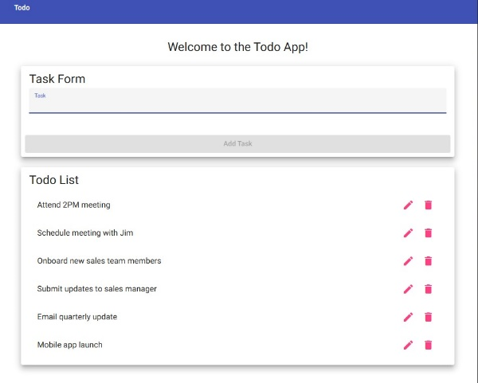
2 | Navigate to https://buwebdev.github.io/todo/crap/ | The Todo webpage confronts you with 404 screen | Yes | Yes  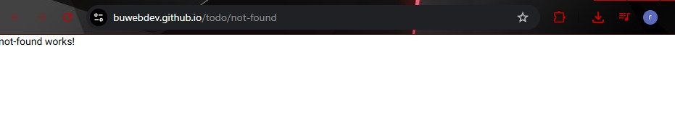
Comments | Web URL navigates to ToDo when using valid link and goes to 404 when using Invalid Link

